**Human Body Name:**

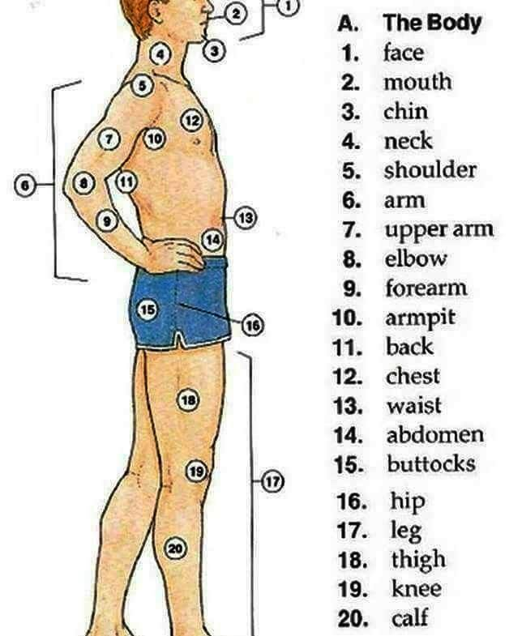



**Human Body Name:**

**Let´s name of Body parts Name:**

**Let´s name of Body parts Name:**

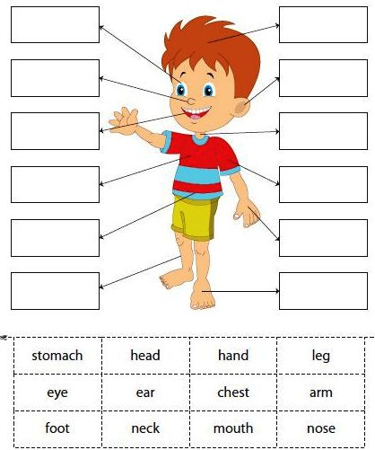



**Let´s name of Body parts Name:**

**Let´s name of Body parts Name:**

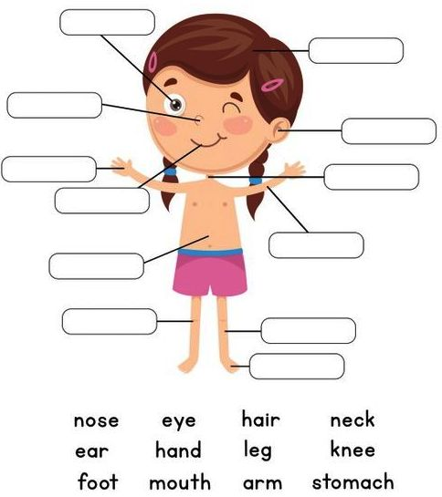



**Let´s name of Body parts Name:**

**Let´s name of Body parts Name:**

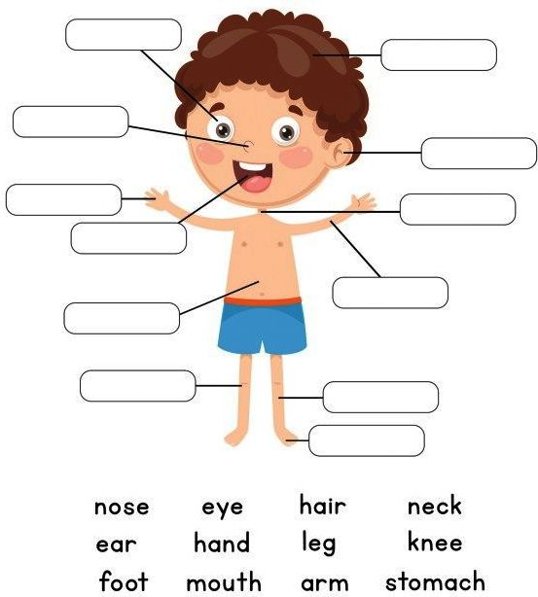



**Human Body Name:**

**Human Body Name:**

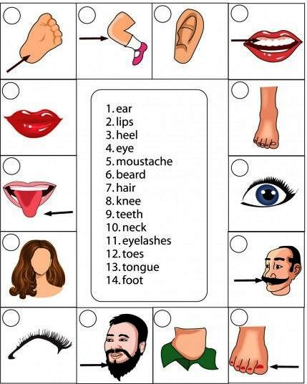



**Human Body Name:**

**Human Body Name:**

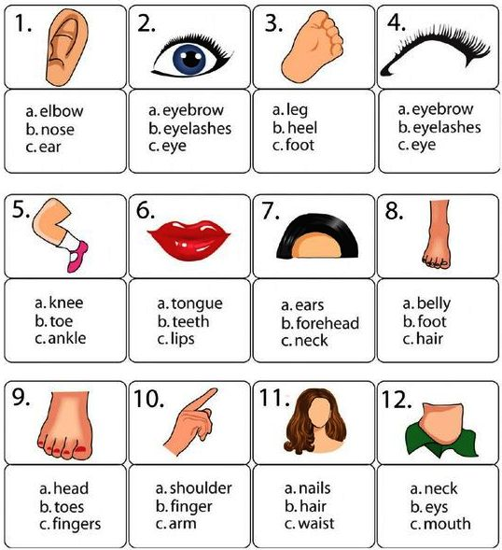



**Human Body Name:**

**Human Body Name:**

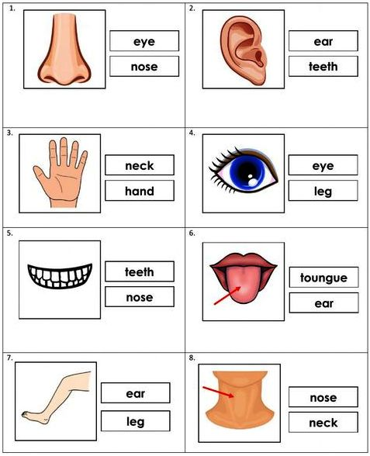



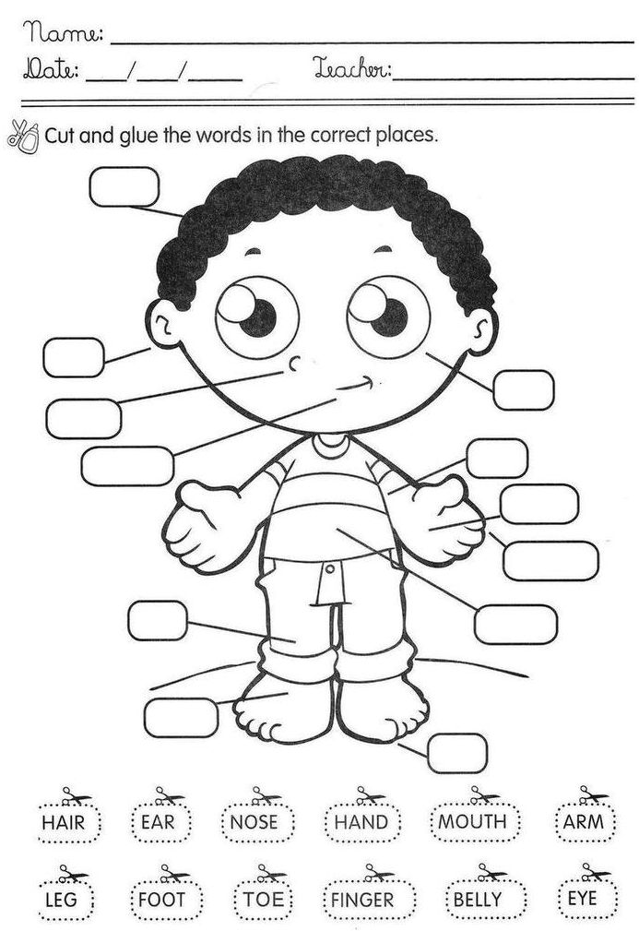



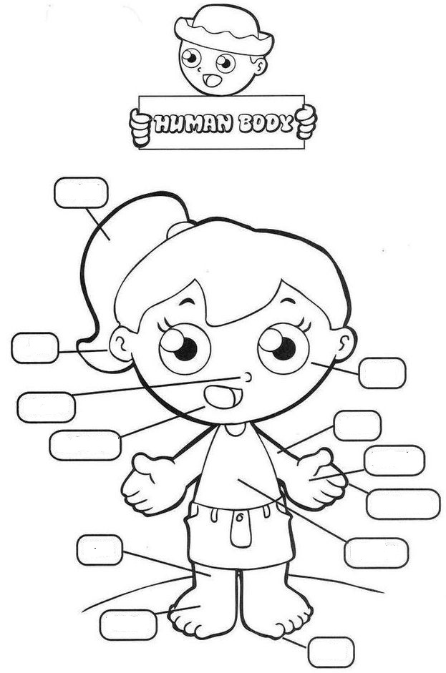

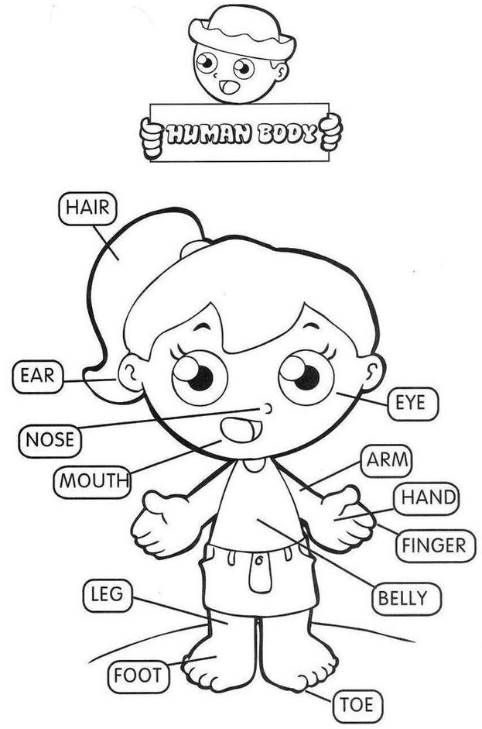

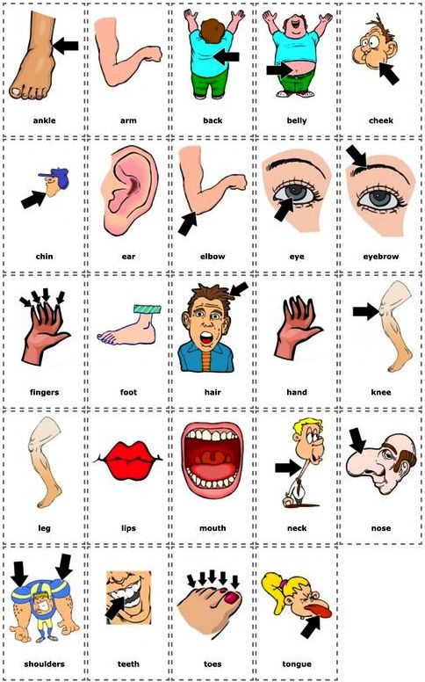



**Human Body**

**Human Body**

